Phase 1 — Design
Business Requirements
↓
Source Identification
↓
Source → Table Mapping
↓
Table Columns / Schema
↓
Load Strategy

Source to target Mapping: Design Concept
The source doesn't automatically determine the ingestion method.
We're choosing these patterns deliberately for this tutorial so that we can learn different
Types of data ingestion
CSV → Full-load batch /initial snapshot load
SQL → Incremental batch
REST API → Micro-batch based incremental load
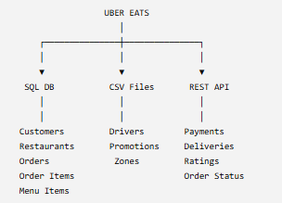

SQL Database
Table | Important columns
customers | customer_id, customer_name, email, phone, city, signup_date, updated_at
restaurants | restaurant_id, restaurant_name, cuisine, city, rating, status, updated_at
orders | order_id, customer_id, restaurant_id, order_date, order_status, total_amount, updated_at
order_items | order_item_id, order_id, menu_item_id, quantity, unit_price, item_total
menu_items | menu_item_id, restaurant_id, item_name, category, price, is_available, updated_at

CSV Files
File | Columns
drivers.csv | driver_id, driver_name, phone, vehicle_type, city, join_date, status
promotions.csv | promo_id, restaurant_id, promo_code, discount_type, discount_value, start_date, end_date
zones.csv | zone_id, city, zone_name, latitude, longitude

REST API
Endpoint | Columns
/payments | payment_id, order_id, payment_method, amount, payment_status, payment_timestamp
/deliveries | delivery_id, order_id, driver_id, pickup_time, delivery_time, delivery_status
/ratings | rating_id, order_id, customer_id, restaurant_id, rating, review, created_at
/order-status | order_id, status, status_timestamp

Table to column Mapping:
• Primary keys → identify records
• Foreign keys → establish relationships
• created at / updated_at → incremental loading
• Business/status columns → transformations and KPIs
• Timestamps → analytics such as delivery time and peak hours

Storage Design:

